API DAY 2(POSTMAN SETPU)

- POSTMAN: it is manual testing

Download application: desktop and Web version
Desktop Version:
https://www.postman.com/downloads/

- Create Workspace: (Rename, delete): top there will be workspace
- Create Collection: File – new – Collection
- Create Request: Payload means data
Note: Request API Response
Here only we will write request GET, POST, PUT or PATCH, DELETE
Http requests:
- GET- gets the data from DB
- POST- Create new data in DB
- PUT Update full existing data on DB
- PATCH: Update only partial data on DB
- DELETE: Delete existing data from DB

Sample API: this is taken from google
https://reqres.in/api/users?page=2
https://reqres.in: Host
/api/users?: Path perimeter
page=2: Query perimeter(After ?)

Step 1: Collection – >My-Collection – 1 –> add request
Step 2: Name the Request
Step 3: Enter the GET URL from the excel
Step 4: Click send: We will get response: We want to note the status code 200

Validations:
- Status code
- Time
- Size
- Response body (JASON/xml code)
- Cookies
- Header
- Step 5: Save
- Step 6: Now Enter POST URL – This will create new data in data base

- My-collection – 1 - add request:

- Step 1 create post and enter POST URL from excel
- Step 2 Go to body – raw select – JSON and paste the code - send
- Step 3: Note the ID that is main

- Step 7: Now Enter PUT URL with ID – This will update old data in data base
- Step 8: Now Enter DELETE URL – This will update old data in data base

- HTML STATUS CODE:
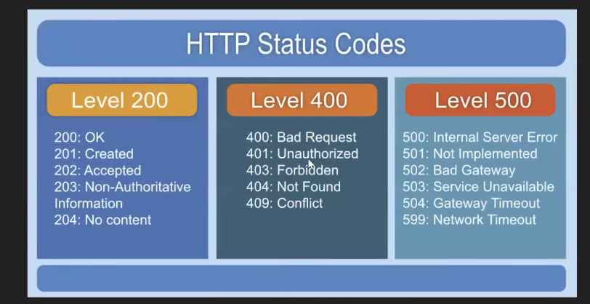

- EXPORT & IMPORT
Export:
MyCollection – 3dots – more – Export collection it will redirect to folder
Import:
